**Chelsea Miller**

**Portfolio**

If you were at a loud party and had 30 seconds to describe your site to someone who had never heard of it, what you would tell them? Write it down.

TL;DR

The Problem

Limitations

Solutions

Your Role

Be concise!

Template:

Role:

Project Type

Team

Platform:

Tools:

Timeline:

Summary

Brainstorm

Personas

Sketching & Ideation

Paper Prototype & User Testing

Digital Prototypes

Final Design

Takeaways

**MUNGER EVENTS**

Facilitating transdisciplinary collaboration and innovation at the Munger Graduate Residences through transparent program development.

Please explore the prototype, then read more about my design process below.

**Interactive prototype**

Role: Interaction Designer, UX Researcher

Project Type: Individual project for the Interaction Design course at the University of Michigan

Timeline: September – December 2016

Tools: Paper Prototyping, Sketch, Invision

**The Community**

The Munger Graduate Residences is a transdisciplinary community for graduate and professional students from all 19 schools at the University of Michigan. As a Coleman-Munger Fellow, I lead residents in developing programs and events that encourage collaboration and innovation across disciplines.

Munger has only been open since Fall 2015, which means we also need to figure out how to create a more effective and transparent process by which residents can create and promote programs.

**The Opportunity**

In conversations with staff and residents, several recurring types of questions about events and programming at Munger tend to surface. These same themes were consistent with three types of common questions posted on the Munger Facebook group, which I’ve grouped as follows:

1. **What’s going on tonight?**

Residents often approach or email staff members asking about an event they see in progress in one of the building’s common spaces. These questions highlight two current concerns:

* No central resource for residents to view or learn more about events going on in the building at any given time
* Residents unsure whether they are welcome to attend certain events- whether they are closed/private functions, or open to all residents.

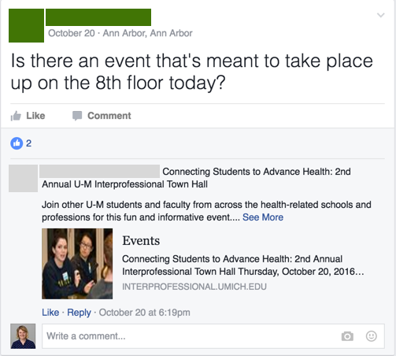

1. **How can I share my event with the community?**

The Munger Facebook group is currently the widest platform residents can use to promote their programs. However, not every resident is a member of the group, and users have experienced difficulties utilizing Facebook events as a central resource for community event sharing.

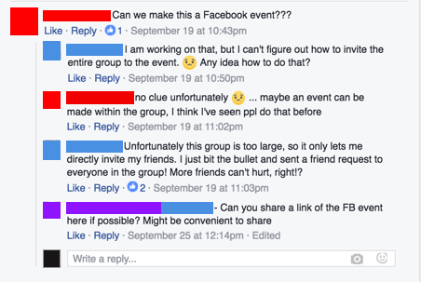

1. **Will anyone attend my event?**

As a new community, Munger collectively has a limited amount of data and experience to consult when considering whether there is enough resident interest in a program idea, or which dates and times would best meet the needs of a diverse group of students with busy schedules.

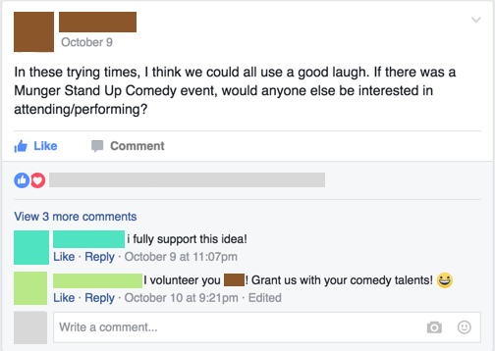

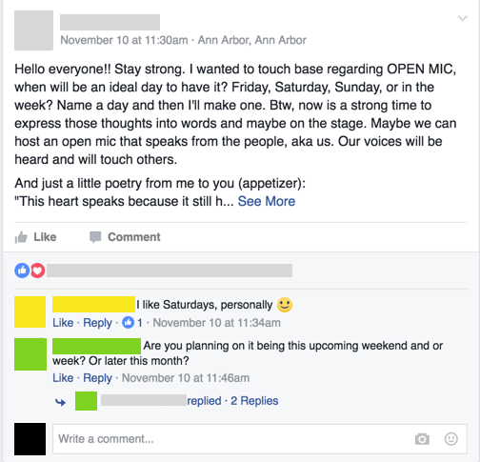

Essentially-

No central resource to **find** events. Scattered between:

* Facebook
* Email
* Posters
* Word of mouth

No central resource or process on **how to plan** events:

* Contact a Fellow?
* Distribute posters?
* Post on Facebook?

**Goals**

**Demystify program creation**

**Create a more inclusive community**

**Empower community members pursue their ideas collaboratively**

**The Solution**

After conducting preliminary research, I developed personas, sketched scenarios, and constructed paper prototypes of possible solutions.

**Personas, sketches, Video of paper prototype**

By testing the paper prototypes with target users, I was able to better identify the priorities of residents and iteratively improve on the design.

My digital prototype demonstrates several key features of the platform.

1. Event proposal and editing
   1. Users can create, promote, and manage the logistical details about their events, allowing them to inform their guests easily and quickly of any last-minute changes (room, date, time, etc).
   2. Users can view the guest list of interested residents before the event, to better prepare for food ordering or further promotion.
   3. Users can provide feedback on the events they’ve hosted or attended in order to gather more data on the best dates, times, and locations for certain types of events. This will facilitate future event planning decisions.
   4. Users can share events they are interested in attending with their friends, which can then be added to the user’s main calendar.

**Takeaways**

Overall, this process has led me to consider the differences in designing platforms that are meant to share and promote events widely- through large cities, for example- and those tailored for the needs of smaller communities.

Some important considerations as I move forward include possibly integrating Munger Events with other social networking or productivity platforms to provide users with more flexibility and to gain wider adoption. I plan to further test:

* Is an internal calendar optimal, or should users be able to sync events with other calendar services?
* Should event sharing be limited to internal use only, or are there avenues by which events could be shared through email, text, or other messaging applications?

**DATA CONCIERGE**

**Streamlining the data request process and building a data community at the University of Michigan.**

Role: Consultant, UX Researcher

Project Type: Client-based team consulting project for SI 501: Contextual Inquiry at the University of Michigan

Team: Julie Cruz, John Posch, Ling Zhong

Timeline: September – December 2016

Methods & Skills: Contextual Interviews, Affinity Mapping

**the client**

Our client is a newly-formed department within the university that supports higher-level university administrators and executives with their data needs and envisions a ‘data-as-a-service’ delivery model.

**the opportunity**

Data requesters across university departments are often inconvenienced by long wait times and nonresponsive outcomes after placing a data request with another unit. Our client began development of a ‘Data Concierge’ platform to serve as a one-stop-shop for requests to be triaged and fulfilled.

Our team investigated ways in which the Data Concierge could facilitate data requesting at U-M over time, with two overarching research questions guiding our process:

What are the specific steps, challenges, and opportunities that currently exist in the data requesting process at U-M?

How do the stakeholders feel about the data request process, and how could they accomplish their data needs in a more efficient and satisfying way?

**Methods**

Our group first conducted background research in:

Data stewardship roles and responsibilities

Data hierarchies and documented system limitations at the University of Michigan

The implementation of business intelligence using data systems in higher education

Data-as-a-service and its implementation in higher education

We then conducted contextual interviews and performed field observations with stakeholders located in 7 different units across the university. Through an extensive affinity diagramming process, our team categorized interview content, quotes, and other contextual information to uncover some affirming and also surprising insights into the data request process.

**findings and recommendations**

Finally, we developed a report of our findings and recommendations, summarized below, which we presented to our client team of over 30 project managers, developers, and information architects. A full version of our report is available upon request.

Recommendation 1: Develop a browsable catalog & interactive data community forum to assist data requesters when they are not sure what to request, who to request from, or how to properly express their needs to data stewards.

<imgs>

Recommendation 2: Implement a visual workflow process of request so requesters can track of the status of their request fulfillment.

<imgs>

Recommendation 3: Integrate an interactive and customizable Memorandum of Understanding to streamline the approval process and reduce logistical conversations between stewards and requesters.

<imgs>

Recommendation 4: Build enhanced and searchable data dictionaries to ensure critical usability information is accessible to users browsing data sets.

<imgs>

Recommendation 5: Incorporate purpose-driven facilitators into the data access model to bridge the gap between data silos and empower researchers to collaborate between disciplines.

<imgs>

**the takeaway**

**Cyclika**

**Paving a sustainable path towards empowered biking.**

Role: UX Researcher and Designer

Project Type: Group project in product design entered into the CHI Student Design Challenge

Team: Ankita Gupta, Navdeep Bagga, Marisa Xheka, Phuong-Cat Ngo

Timeline: September – January 2017

Software: Sketch, Adobe Photoshop, Final Cut Pro

Methods & Skills: Contextual Interviews, Sketching, Paper Prototyping, Usability Testing, Digital Prototyping

**the community**

We asked ourselves how we could improve bike safety for hearing-impaired individuals. Through our initial interviews and design process, we realized that these safety concerns significantly affect the habits of cyclists of diverse ages and experience levels, especially those who typically ride in busy, traffic-filled roads that lack bike lanes or similar protective infrastructure.

**the opportunity**

According to a 2012 survey by the US Department of Transportation, 83% of American cyclists feel a threat to their personal safety when motorists drive too fast or too close. Moreover, cyclists living in underserved communities with poor road conditions risk significantly higher rates of injury and fatality.

We sought to develop a tool to empower all individuals to cycle confidently in traffic. By detecting and alerting users of vehicles approaching laterally and from behind, the tool would assist users by informing them of their surroundings and allowing them to take the necessary measures to ensure their safety.

**The methods**

We conducted two rounds of contextual interviews to better understand the experience and concerns cyclists when cycling in traffic. Next, we brainstormed, sketched, and iterated upon digital prototypes after testing with target users.

**the solution**

We developed Cyclika, a system that alerts cyclists of vehicles in their environment. The system consists of two main parts. Users mount a small interface on the center of their handlebars. When a triangle lights up, it indicates that a vehicle is present in relation to the cyclist, represented by the circle at the top. The interface uses space and color to assist users in identifying how close an approaching vehicle is. The interface is visible in the cyclist’s peripheral vision, and can be used during the day and at night.

Cyclika detects vehicles with a radar mounted below the seat. Attached to the radar is a grid of LED lights that cyclists can use to indicate turns. Users can activate the rear lights using buttons on the handlebar.

View a video demonstration of the prototype below.

**the takeaways**

Cyclika won second place in the 2016 Munger Case Competition, a challenge for graduate students across the university to develop solutions to improve sustainable living in Ann Arbor. We are very proud of this honor.

Our team learned a lot about prioritization while developing Cyclika. While we were chiefly concerned during the design process with the product’s usability and efficacy of increasing safety for cyclists, we also aimed to increase accessibility by choosing materials that would keep cost low. While RADAR and LIDAR detection systems are becoming more affordable, their price is still relatively high. However, lower priced detection systems, like cameras, have a much smaller range of detection or other constraints that render them ineffective for our means.

Thus, it is important to prioritize when designing products that strive to be both usable and affordable. As user experience designers, we are here to represent the users. If a low cost is the most important factor driving a design, it is important to consider design choices that improve safety by utilizing less expensive materials.